Operation Manual
Predator SS
SIMPLIFIED STRETCH

LOW PROFILE

SERIAL NUMBER

Please refer to the serial number in all correspondence with Highlight or any Highlight Distributor. This identifies your machine and will help in our ability to quickly and efficiently respond to your needs.

OPERATION MANUAL NUMBER: PREDSS_LP / JANUARY-2012

Table of Contents
Table of Contents 1
Table of Figures 2
General Information 3
Safety Messages 4
Introduction and Warranty 6
Revision History 8
Specifications 9
Specifications 10
System Overview Prints 11
System Description 12
Installation & Adjustments 13
Machine Placement 14
Machine Set-Up 15
Microprocessor Card 18
Optional Scale Package 20
Operation Instructions 23
Operator Controls 24
Film Loading 27
Machine Operating Instructions 29
Maintenance 30
Preventative Maintenance 31
Maintenance Schedule 34
Trouble-shooting 35
Self Test Troubleshooting 36
Troubleshooting Guide 39
Power Problems 40
Turntable Problems 41
Film Carriage Problems 42
Technical References 43
Recommended Spare Parts 44
Electrical Drawings 45
Mechanical Drawings 50
Notes 60
Table of Figures
Figure 1: Predator SS Low Profile Overview Layout 11
Figure 2: Predator SS Low Profile Machine Description 12
Figure 3: Bracket in the Shipping Position 15
Figure 4: Bracket in its Operating Position 16
Figure 5: Microprocessor Card for the Predator SS 18
Figure 6: Operator Controls Diagram for the Predator SS 24
Figure 7: Film Loading/Threading Diagram 27
Figure 8: Turntable Belt Adjustment 32
Figure 9: Film Carriage Lift Chain Adjustment 33
Figure 10: Self Test Error Display 37

1
Highlight Industries, Inc.
Predator SS Turntable Stretch Wrapper Operation Manual
General
Information
Safety Messages
For the best result with the Predator Turntable Stretch Wrapper, carefully read this manual and all of the warning labels attached to the equipment before installing and operating it, and follow instructions exactly. Keep this manual for machine reference.
Definitions and Symbols


High Voltage!
This symbol indicates high voltage. It calls your attention to items or operations that could be dangerous to you or other persons operating the equipment. Read the message and follow the instructions carefully.


Warning!
This symbol indicates a potentially hazardous situation which, if not avoided, can result to bodily injury, or serious damage to the product.


Notes
This symbol indicates an area or subject of special merit, emphasizing the equipment’s capabilities, common errors in operation or maintenance, or other special instructions that can provide benefits to users.

General Precautions – Read These First!

High Voltage!
Disconnect AC input power before checking components, performing maintenance, cleaning up, and when the machine is not in use. Do NOT connect or disconnect wires and connectors while power is applied to circuit.

High Voltage!
Wiring work should be carried out only by qualified personnel. Otherwise, there is a danger of electric shock or fire.

High Voltage!
The user is responsible for conforming to all applicable code requirements with respect to grounding all requirements. Do NOT use extension cords to operate the equipment.

High Voltage!
Motor control equipment and electronic controllers are connected to hazardous line voltages. When servicing drives and controllers, there may be exposed components with housings or protrusions at or above line potential. Extreme care should be taken to protect against shock.

Warning!
Loose clothing must NOT be worn while the machine is in operation. Stay clear of moving parts while the machine is running.
Introduction
Introduction and Warranty
Thank you for your purchase of a Predator SS Turntable Stretch Wrapper! Designed for the high volume industrial user the Predator SS will stretch wrap any load to the maximum stretch level of any film with full independent control of the film force. This allows even light unstable loads to be wrapped at the lowest possible cost and the maximum load holding force.
Limited Warranty
Highlight Industries, Inc. warrants its Predator manufactured by it, and sold pursuant to this order, will be of merchantable quality, free from defects in material and workmanship as determined at the date of shipment, by generally recognized, applicable and accepted practices and procedures in the industry, for a period of three (3) years from the Highlight invoice date, under normal use and service.

When the Purchaser gives Highlight written notice of any alleged defect within the applicable warranty period, Highlight will, at its option repair or replace the same free of charge F.O.B. its manufacturing plant, installation not included. Equipment replaced under the warranty shall have the same warranty as new equipment but does not extend the warranty of the original equipment.

Satisfaction of this warranty, consistent with other provisions herein, will be limited to the replacement or repair or modification of, or issuance of a credit for, the equipment involved, at Highlight’s option.

Highlight neither assumes nor authorizes any person to assume for it any other obligation in connection with the sale of Highlight’s equipment.

This warranty shall not apply to any equipment which has been repaired or altered by un-authorized personnel in any way so as to, in the judgment of Highlight, affect serviceability, or which has been subjected to misuse, negligence, accident, or to equipment made by Highlight which has been operated in a manner contrary to Highlight’s instructions.

In no event regardless of the cause, shall Highlight be liable for penalties or penalty clauses of any description or any damages resulting from loss of profits, use of products or for any incidental indirect or consequential damages, even if advised of the possibility of such damages. This limitation of Highlight’s liability will apply regardless of the form of action, whether in contract or tort, including negligence. Any action against Highlight must be brought within twelve (12) months after cause of action accrues.

“This warranty in lieu of all other warranties whether expressed, implied or statutory including implied warranties of merchantability of fitness or extends only to the buyer or customer purchasing from Highlight Industries, Inc or an authorized distributor.”
About This Document
The purpose of this manual is to provide you with information necessary to install, operate, troubleshoot, and maintain the Predator SS Turntable Stretch Wrapper. The audience for this manual should have basic knowledge of mechanical and electronic components, standard electrical wiring practices, and schematics symbols.

To guarantee safe operation of the equipment, carefully observe the safety messages throughout this manual. Keep this operating manual and distribute it to all users for reference.
Application Assistance
If any assistance is desired, contact the distributor from whom you have purchased the unit, or call the number listed on the bottom of each page of this manual. To receive quick and proper technical support for the equipment you have purchased, please be prepared to provide the following information:
- Machine Serial Number
- Date of Purchase
- Symptoms of any problems
Revision History
Revision | Revision Comment | Date of Revision
 | Initial Release | November 2005
1 | Revised Entire Manual Format | August 2007
2 | Revised Optional Scale Package | April 2008
3 | Change to AC Fan | November 2009
4 | Added Spare Parts List | January 2010
5 | Updated Drawings and Spare Parts | March 2011
6 | Revised Entire Manual Format | January 2012
7 | Added 30” carriage parts | 2/12/13-RDU
8 | Updated TT cam roller & belt idler bearing number | 7/2/13-RDU

Machine Dimensions
2
Highlight Industries, Inc.
Predator SS Turntable Stretch Wrapper Operation Manual
Specifications

Specifications
 | Low Profile
Length (inch) | 98
Width (inch) | 60
Height (inch) | 91
Turntable Diameter (inch) | 60
Turntable Height from Floor (inch) | 3.25
Operation Space (inch) | 105 x 75 x 120
Maximum Pallet Size (inch) | 52 x 52 x 72
Shipping Weight (lbs) | 1050
Electrical Specifications
- 120VAC, 60Hz, Single Phase, 15Amp
Turntable
- 4,000 lbs Maximum Turntable Load Capacity
- 12 RPM Maximum Turntable Speed
- 20-30 Loads Per Hour
Film Carriage
- Adjustable Raise and Lower Speeds
- Automatic Package Height Detection
Film Delivery
- Infinite/Manual Film Force Adjustment
- 10 Inch Diameter Roll Capacity
- 20 Inch Height Roll Capacity (30 Inch Optional)
System Overview Prints
Note
Shown below are STANDARD assembly drawings. It may not reflect your purchased system, especially when optional items are added. Refer to the Technical References section of the manual for more detailed information.
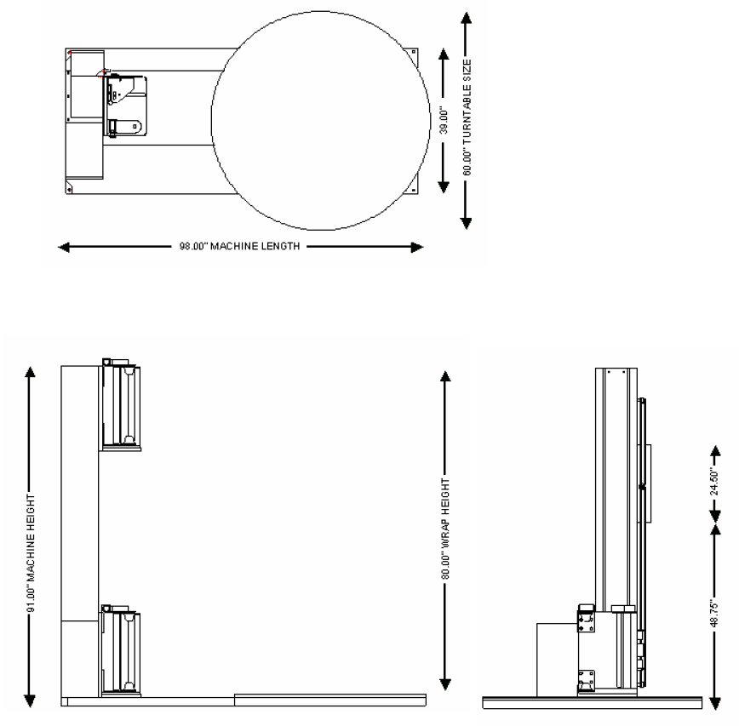
Figure 1: Predator SS Low Profile Overview Layout
System Description
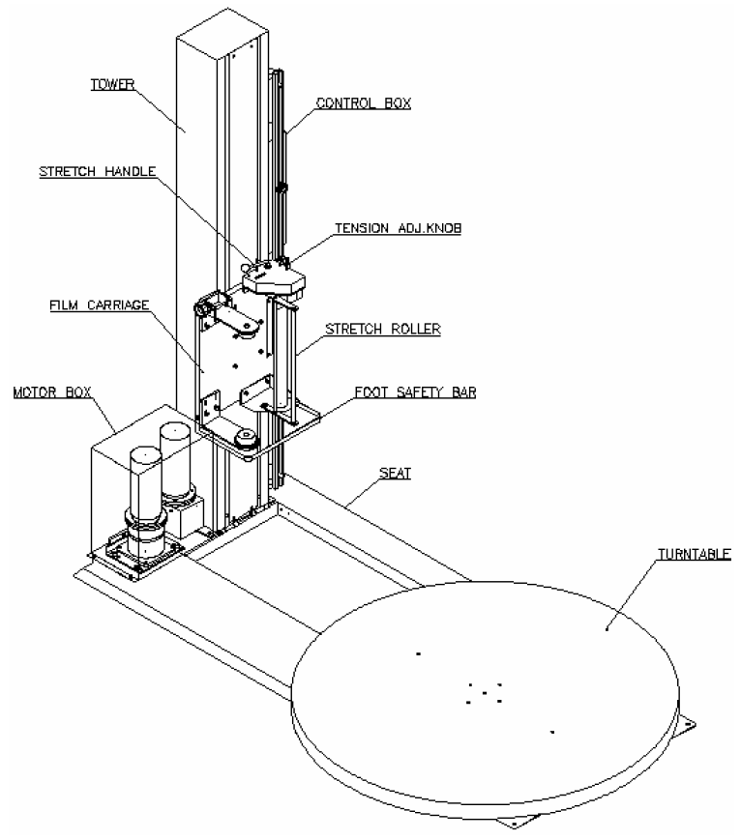
Figure 2: Predator SS Low Profile Machine Description

Receiving and Inspections
3
Highlight Industries, Inc.
Predator SS Turntable Stretch Wrapper Operation Manual
Installation & Adjustments

Machine Placement
The Predator Turntable Stretch Wrapper has gone through quality control tests at the factory before shipment. Upon receiving, please do the following:

- Inspect the entire machine for visual damage during shipment. If found, immediately report this damage to the trucking line. Highlight Industries, Inc. has taken every precaution during the packaging and loading of this equipment, however, it is YOUR RESPONSIBILITY to inspect for damage before installation.

- Make sure the part or serial number indicated on the machine corresponds with the part number of your order.
Positioning of the Machine
Place the Predator Turntable Stretch Wrapper close to an area where you will be wrapping your loads. Make sure that there is sufficient room to load/unload the machine and that you do not stretch the power cable. Remember, you will need to plug the machine in to a 120VAC, 15-Amp outlet.
Floor Weight Bearing/Stress Tolerance
The floor must be able to bear the weight of the machine, the weight of the maximum load, plus a safety factor. The floor must also be able to tolerate the stress of the machine’s operation. If the fork trucks will operate on the same weight bearing area, add the weight of the trucks to the weight bearing stress tolerance requirements.

The Predator can be installed on any type of floor constructions that meets the weight bearing and stress tolerance requirements.

Warning!
The Predator must be anchored securely to the floor, using the type of anchor recommended for your floor.
Unpacking and Moving the Machine
Machine Set-Up
It is very important to read all instructions before undertaking any of these steps. The following steps should help achieving a safe and quick machine set-up.

- Place the skidded machine close to the designated wrap area. Remove all shipping fasteners holding the machine to the pallet. The machine may be crated with the tower tilted down with the motor cover front carriage roller removed for shipping purposes.
- Place the forks of the forklift through the tubes provided on the base of the machine, remove the machine from the shipping skids, and place it in the designated wrap area.
- If the OPTIONAL ramp (Part Number #600086) is purchased:
Select a ramp position as illustrated below. The ramp can be positioned anywhere in a 180° rotation around the front of the turntable. There should be ¼” gap between the turntable and the ramp. The ramp should be fully supported by the floor. Both the ramp and the machine should be lagged to the floor.
- When a machine is ordered with a 110” extended tower or a scale package, the carriage photo eye bracket will need to be unbolted from its shipping position (Figure 3) to its operating position (Figure 4).

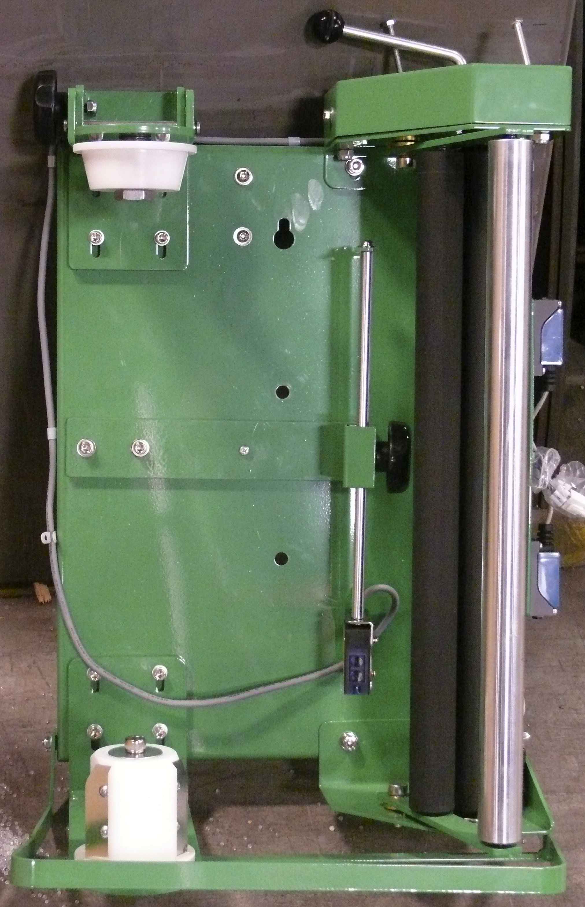
Figure 3: Bracket in the Shipping Position
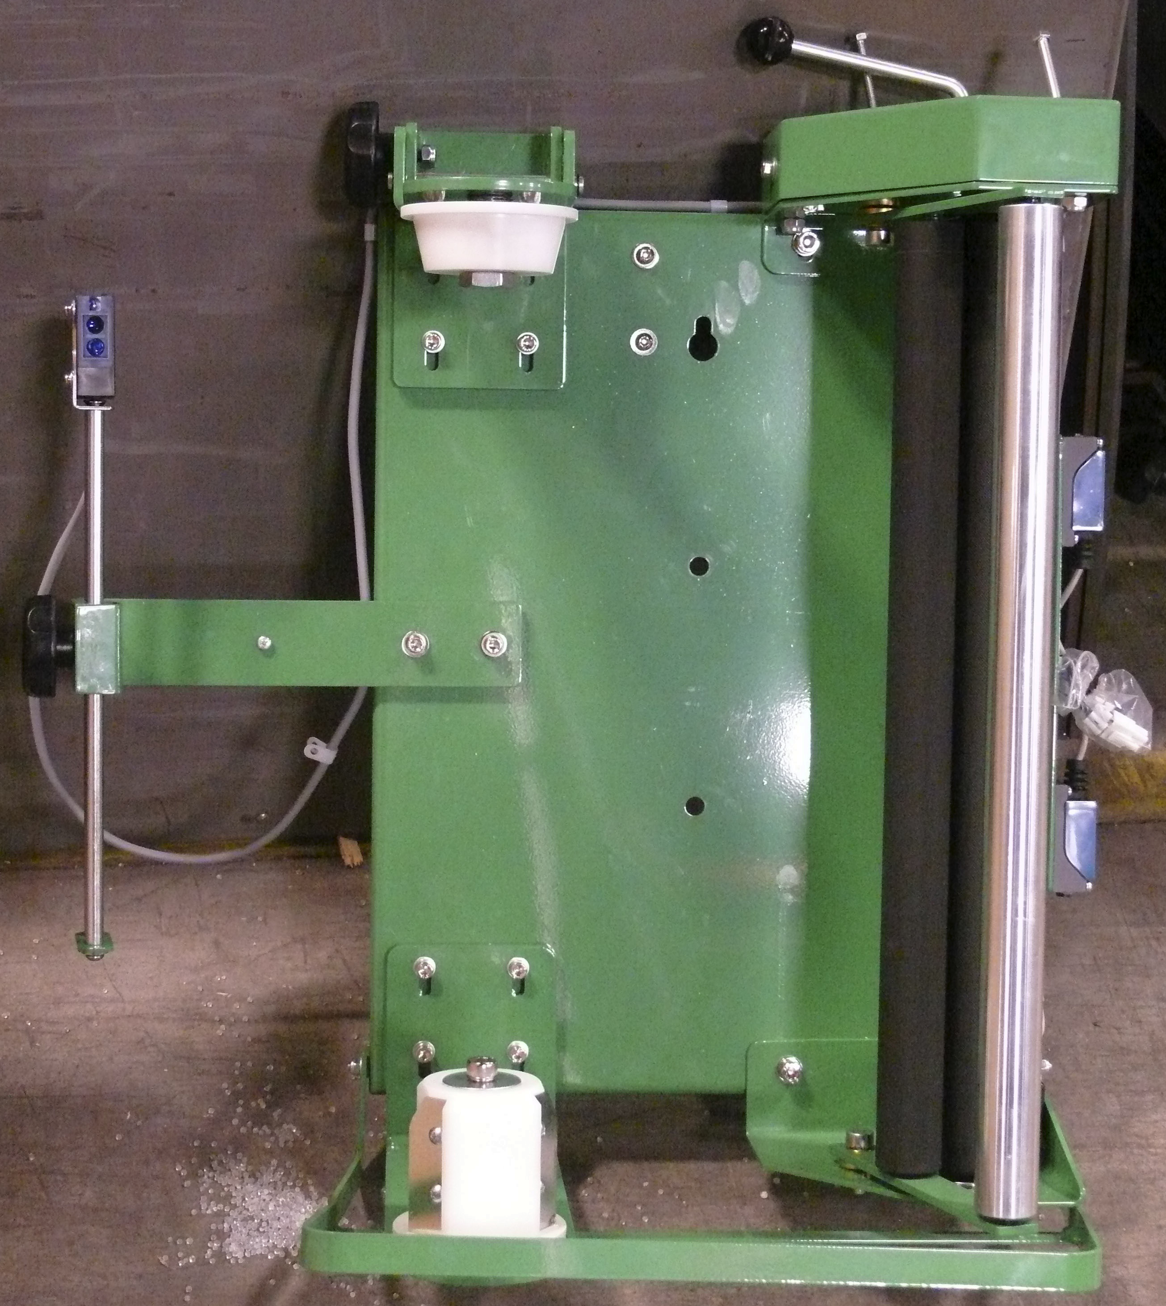
Figure 4: Bracket in its Operating Position

Warning!
It is very important that the machine be leveled. Uneven floors will cause premature turntable support roller failure.

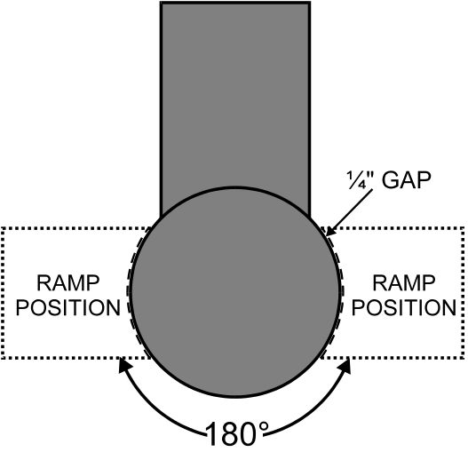
Figure 5: Ramp Position for the Predator SS Low Profile

Power and Control Wiring Checks
- Using a volt meter, check the AC voltage coming to the machine and insure the proper voltage is present.

- Make sure the Emergency Stop button on the operator panel is fully pressed in. Turn the disconnect switch to the ON position. Power should be applied to the drive board, operating touch-panel, photoelectric sensors, switches, and LED’s.

- Press the Emergency Stop button. Make sure all machine power is completely removed when the Emergency Stop button is depressed. Pull the Emergency Stop button out to resume.

- Open the electric control box. Make sure all machine power is completely removed when the electrical control box is open. Close the electrical control box to resume.

- Trip the carriage foot security bar. Make sure all machine power is completely removed when the carriage foot security bar is tripped. Clear the bar to resume.
Warning!
Ensure that the Emergency Stop button light is ON when the button is pushed in and OFF when the button is pulled out.

Microprocessor Card
Microprocessor Card Description
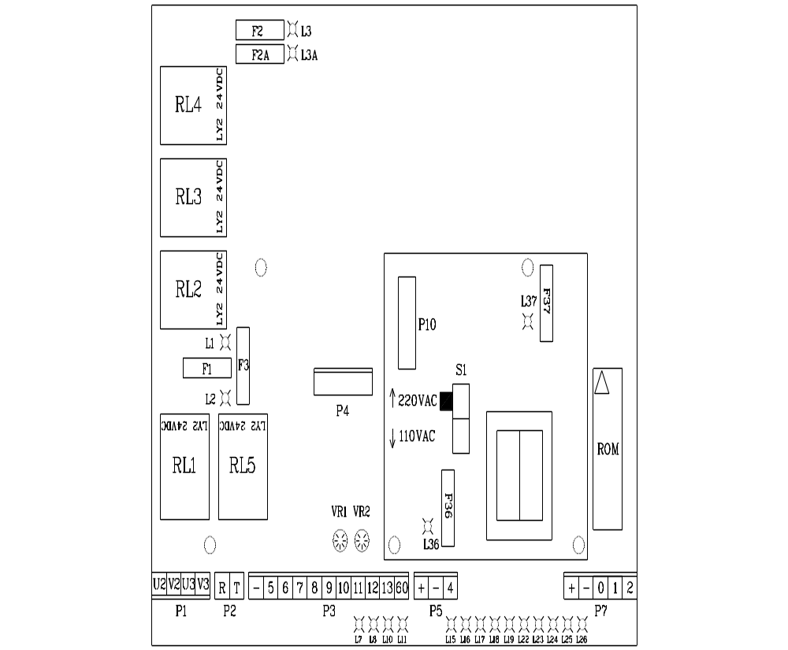
Figure 5: Microprocessor Card for the Predator SS

S1: Operating voltage selector (220 VAC or 110 VAC)

Connector P1: Turntable/Film Carriage Relay Output
Connector P2: Power Input
Connector P3: Operator Panel Input
Connector P4/P10: Transformer Input/Output
Connector P5: Turntable Proximity Sensor Input
Connector P7: Film Carriage Limit Switches Input

Relay 1: Film Carriage Down
Relay 2: Film Carriage Up
Relay 3: Turntable/Film Carriage Stop
Relay 4: Power Input
Relay 5: Turntable Running

Fuse 1: Carriage Motor (5 Amp)
Fuse 2/2A: Power Input (10 Amp)
Fuse 3: Turntable Motor (5 Amp)
Fuse 6: Transformer Input (1 Amp)
Fuse 7: Transformer Output (1 Amp)

LED 1 is ON: Film Carriage Motor fuse is blown
LED 2 is ON: Turntable Motor fuse is blown
LED 3/3A is ON: Power Input fuse is blown
LED 7 is ON: Cycle starts
LED 8 is ON: Film Carriage is moving up
LED 10 is ON: Film Carriage is moving down
LED 11 is ON: Turntable is rotating
LED 15 is ON: Start Button is pushed
LED 16 is ON: Pause Button is pushed
LED 19 is ON: Package Height Photo Sensor is unblocked
LED 23 is ON: Carriage Max Up Limit Switch is not tripped
LED 24 is ON: Carriage Max Down Limit Switch is tripped
LED 25 is ON: Emergency Stop Button is not pushed
LED 26 is ON: Turntable Home/Count proximity switch is blocked
LED 36 is ON: Transformer Input/Output is blown

VR1: Film Carriage Max Speed setting
VR2: Turntable Max Speed setting

Replacing Microprocessor Card
- Turn the disconnect switch to OFF position.

- Removed the old microprocessor card by pulling all connectors off and loosening the four mounting screws.

- Install the new microprocessor card; connect all connectors and tighten the mounting screws.

- Turn the disconnect switch to ON position. The display should show “- -“. If not, check all connectors and fuses again.

The optional scale package allows the user to quickly measure the weight of the package placed on the machine. To operate correctly and efficiently the scale needs to be configured with the correct settings. Below are the instructions on how to re-configure the scale and the settings that have been pre-programmed. Re-configuring the scale is not required unless there is a problem with the existing scale or a new scale is added to the machine. Refer to the scale manual for more information.
Optional Scale Package
Note
Changing the scale parameters to values other than the Highlight recommended values may result in poor scale operation.

Navigating the Scale Menu

Step 1: Turn the scale display over so you are looking from above down at the back side of the scale and turn off the scale power.

Step 2: Remove the two small screws holding a small plate on the back of the scale.
Step 3: Looking down at the scale, move the switch under the plate to the right.
Step 4: Turn the scale power back on.
Step 5: Press the “PRINT / >>” button until the desired setting appears on the screen.
Step 6: Press the “ZERO” button to enter the parameter set-up.
Step 7: Press the “PRINT / >>” button until the display reads the correct setting and press the “SET / NET” button.

Step 8: Turn the power back off, move the switch under the plate to the left, and turn the power back on.

Step 9: Replace the screws on the back cover and retighten the scale swivel grips on the side.

Step 10: The scale is now ready to use.

Highlight Recommended Configuration Values:
Note
Changing the scale parameters to values other than the Highlight recommended values may result in poor scale operation.

Name/Code | Description | Highlight Recommended Value
F1: Graduations | Specifies the number of full-scale graduations. Value should be consistent with legal requirements and environmental limits on the useful system resolution. | 5000
F2: Span Gain | Span Gain is related to A/D integration time. The larger the span gain, the higher the internal resolution, but the slower the update speed. Note that the scale must be re-calibrated whenever this parameter is altered. See Appendix C in the scales manual for more information. | 100
F3: Zero Track Band | Selects the range within which the scale will automatically zero. Note that the scale must be in a standstill to zero the scale. | 3
F4: Zero Range | Selects the range within which the scale may be zeroed. Note that the indicator must be in standstill to zero the scale. | 100
F5: Motion Band | Sets the level at which motion is detected by comparing the present display update with the previous one. If motion is not detected for two seconds or more, scale is in standstill and can process a Print or Zero command. Maximum value varies depending on local regulations | 1
F6: Digital Filter | Averages weight readings to produce higher stability but the slower the indicator’s response time. Choose 8 unless a very fast response is needed. | 8
F7: Overload Limit | Selects the desired formula which determines the point at which the indicator shows overload. All selections are based on the primary unit selected in F8. | 2%
F8: Calibration Unit | Selects the primary base unit to be used in the calibration process. Also the default unit for normal operation. 1 = pounds, 2 = kilograms. | 1
F9: Display Divisions | Determines the desired weight increments. Value should be consistent with legal requirements. | 1
F10: Decimal Point | Determines the location of the decimal point. | 0
F16: Zero Calibration | Places the scale in a Zero Calibration routine. | See below.
F17: Span Calibration | Places the scale in a Span Calibration routine. See below. | See below.
Scale Calibration Procedure

Note
Highlight Industries, Inc calibrates the scale before shipment using known weights. The values stored in theses settings are custom per scale and machine. Do not change these values unless directed to do so by Highlight personnel.

Step 1: Navigate the scale menu to parameter “F 16.”

Step 2: Press the “ZERO” button ONCE. This enters the Zero Calibration Menu. The display will momentarily show “C 0” followed by a value.

Step 3: After making sure that there are no test weights on the machine press the “ZERO” button again. The display will zero.

Step 4: Press the “SET / NET” button to save the zero point value. The display will show “EndC0” momentarily then revert to parameter F16.

Step 5: Navigate to parameter “F 17.”

Step 6: Press the “ZERO” button ONCE. This enters the Span Calibration Menu. The display will momentarily show “C 1” followed by a value with one flashing digit. This value will be zero with the decimal point parameter selected in F10.

Step 7: Place a known weight on the machine. Ensure that the test weight is below the maximum capacity of the scale and above 1% of the maximum capacity of the scale.

Step 8: Key in the weight of the test weight using the buttons on the screen. Press the “TARE / <<” button to select the digit to the left of the current position. Press “PRINT / >>” to select the digit to the right of the current position. Press “UNITS” to increase the value of the digit and press “ZERO” to decrease the value of a digit.

4
Highlight Industries, Inc.
Predator SS Turntable Stretch Wrapper Operation Manual
Operation Instructions

Operator Controls
The operator panel for the Predator SS is shown and described as follows:

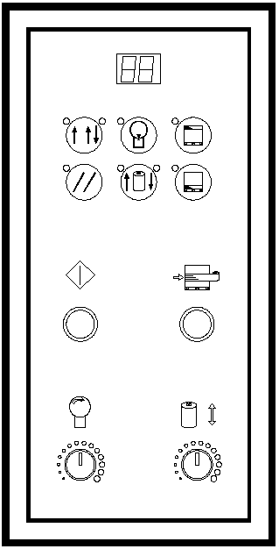
Figure 6: Operator Controls Diagram for the Predator SS
 | FUNCTION
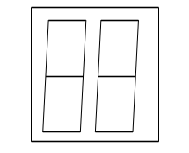 | This displays the system information:  EO = Emergency Stop condition  - - = System is normal  - - Blinking = PWS is bad or both carriage up and down are on  A = Mode A is selected  B = Mode B is selected  CO = Continue operation by pushing START button  S = System is in Manual
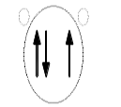 | This displays the selected wrapping mode:  Mode A = The LED light on the button’s upper left is on. In Mode A, the bottom wrap is applied first, and then the top wrap follows. The film carriage comes down to its home position after wrapping cycle is finished.  Mode B = The LED light on the button’s upper right is on. In Mode B, after a bottom to top wrapping is completed, the carriage stays on the top. The START button flashes at this point. To resume the operation, push START. When the carriage reaches the bottom, the START button goes off. Push START button again to begin a new cycle.
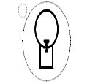 | The TURNTABLE JOG button allows you to manually operate the turntable. When this button is pushed, the light on the button’s upper left is on. Push START button to run the table. Pushing the button again will stop the turntable, and the light will turn off. This button may be used in conjunction with the CARRIAGE JOG button.
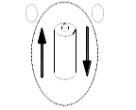 | The CARRIAGE JOG button allows you to manually operate the carriage. When this button is pushed, one of the lights on the button’s upper right or left is on. The upper left light indicates that the carriage will go up when the START button is pushed. Conversely, the upper right light indicates the carriage will go down when the START button is pushed. To pause the operation, simply push this button again. Both indicator lights will go off. This button may be used in conjunction with the TURNTABLE JOG button.
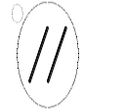 | Push this RESET button, followed by a START button, to reset the system. The turntable will return to its home position, and the carriage will lower all the down.
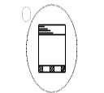 | Push this TOP WRAPS button to select the number of top wraps desired (0 to 9).
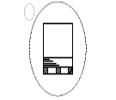 | Push this BOTTOM WRAPS button to select the number of bottom wraps desired (0 to 9).
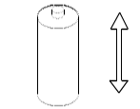 | Turn the CARRIAGE SPEED adjustment knob clockwise to increase, and counterclockwise to decrease the carriage speed.
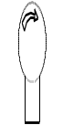 | Turn the TURNTABLE SPEED adjustment knob clockwise to increase, and counterclockwise to decrease the turntable speed.
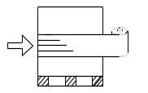 | The BANDING button is used for applying multi-layer reinforcing wraps in automatic or manual mode. Push and hold this button: the carriage will stop raising/lowering. When released, the carriage will resume its movement.
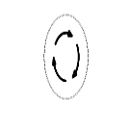 | The EMERGENCY STOP button stops the turntable in the event of emergency. This will NOT stop the turntable instantly. The turntable will coast to a stop, depending on the load’s weight, after this button is pushed.
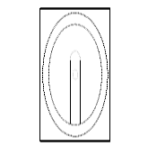 | This switches the main power ON or OFF.

WARNING!
The FOOT SAFETY BAR, located underneath the film carriage, works only when the machine is ON. When the bar is activated, the main power will shut OFF. Releasing the bar will re-activate the main power. Push START button to resume the operation.

Film Loading
Follow the procedure below to thread the film onto the Film Carriage.

Warning!
Be sure the Emergency Stop button is pressed before threading the film and while the film is being threaded.

- Place the film on the film mandrel.

- Set the Stretch Handel to the OFF position to release the tension. (See figure below)

Stretch Tension Adjustment Knob
Stretch Tension Indicator
Film Feed Diagram
Stretch Handle (in off position)

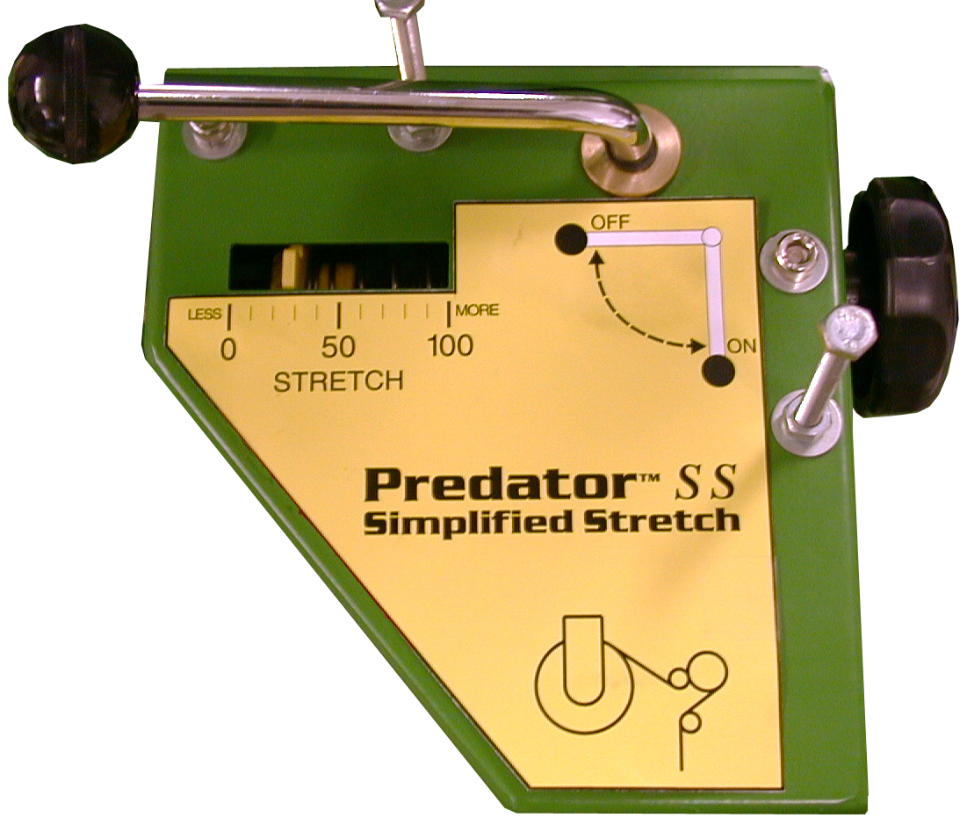

Figure 7: Film Loading/Threading Diagram

- Follow the Film Feed Diagram and thread the 6-foot film tail ALL THE WAY though the rollers.

- After threading, rotate the Stretch Tension Knob clockwise to increase film tension; or counterclockwise to decrease film tension.

- Attach the film securely to the pallet. Tying the end of the film in a knot often helps secure the film to the pallet.
Note
The Stretch Tension numbers (0 to 100) DO NOT indicate the stretch percentage of your film. The numbers are used for reference only.

Normal System Start-Up
Machine Operating Instructions
After the machine has been positioned and supplied with proper voltage, you are ready to begin operating. Read thoroughly and follow these steps to operate your system:

- Place product on the turntable

- Make sure the film carriage is situated at the max down position.

- Thread the film as instructed, and attach it to the product.

- Set the desired number for top and bottom wrap counts.

- Select wrapping made “A”, “B”, or “C”.

- Press the “Start button to initiate cycle.
Stop Condition
Follow the procedure below in the event of an emergency.

- Press the “STOP” button. This cancels the current wrapping cycle and immediately stops the system.

- Correct the problem.

- Pull the “STOP” button out, and then perform normal system start-up procedure.

Note
After pressing the “E-STOP” button, wait for at least 60 (sixty) seconds before pulling the button back out. This will allow the microcontroller card to completely turn off.

Applying Reinforcement Wraps
Automatic operation can be paused in order to apply reinforcement wraps to an additional top sheet or corner boards on the product. Follow he procedure below.

- Press the “START” button as normal to initiate cycle.

- As the carriage travels up, press the “Banding” button. The carriage will stop and reinforcing wraps will be applied.

- Letting go of the “Banding” button will resume the cycle.

5
Highlight Industries, Inc.
Predator SS Turntable Stretch Wrapper Operation Manual
Maintenance
Preventative Maintenance
As with all machinery, proper attention and maintenance is the key to long component life, maximum performance, and safe operation. By spending a few minutes reading and following these preventive measures, you should reduce the downtime and prolong the life of your system.

It is important to understand that these maintenance schedules are minimum recommendations. Highlight Industries, Inc. cannot possibly know, evaluate, or advise the various trades in all schedules of periodic maintenance. Accordingly, anyone who maintains or services a stretch wrap machine must first satisfy himself/herself as to the schedules of preventive maintenance based on cycling operation and environmental locations.
Warning!
All maintenance operations require the equipment to be powered down and locked out for personnel safety.

Lock-out/ Tag-out Procedures
Be sure that anyone performing any type of maintenance on this equipment is familiar with and is adhering to the lock-out/tag-out procedures set forth by the General OSHA or the State OSHA guidelines.
Visual Checks
Visual checks should be conducted at least once per month:

- Keep the machine and surrounding area as clean as possible, especially near moving components.

- Check for loose hardware, especially set screws located in: sprocket hubs, bearing hubs, and flanges.

- Check for oil leaks around the speed reducers.

- Check for dry seals at the bearings.

- Check for chain wear and proper tension on the power roller stretch sprockets. The correct amount of chain tension can be checked by pulling the chain taut and having 3/8” slack.

- Check for loose electrical connections and for frayed cords and cables. Replace immediately any damaged cords and cables.
Turntable Belt Adjustment
Refer to the figure below to adjust the turntable belt. First, loosen the four motor flange (M10) screws. Turn the (M10) bolt on the adjuster tab until the belt is tensioned. Retighten the four motor flange screws.

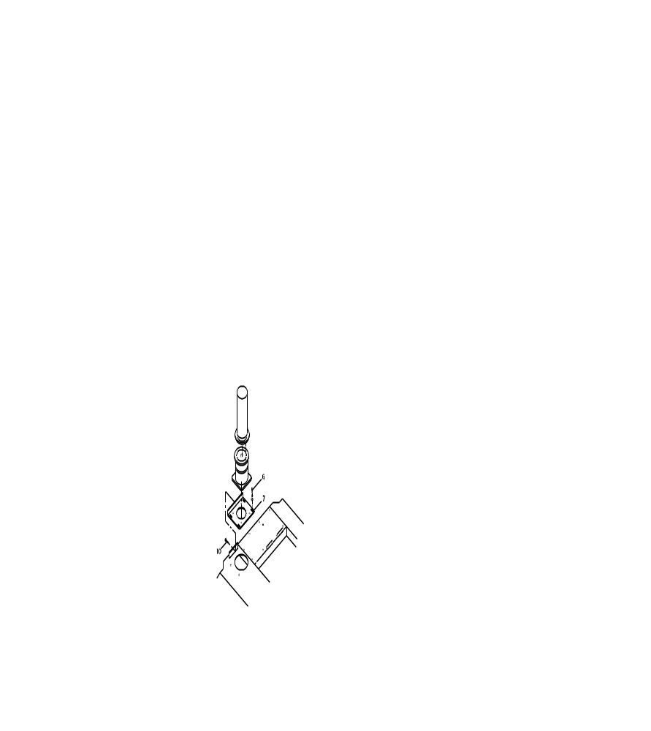
Figure 8: Turntable Belt Adjustment
Film Carriage Lift Chain Adjustment
Refer to the figure below to adjust the film carriage lift chain. First, loosen nut (M12) on the adjustment bracket. Turn the bottom bolt until desired tension is achieved. Retighten nut (M12). Note that the driving chain and adjustment bracket should be parallel with the movable pulley base.

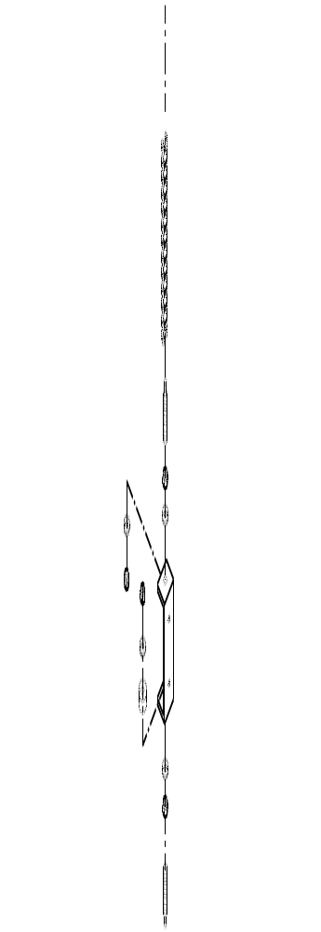
Film carriage raise/lower chain

Threaded rod
Tensioning nuts

Bracket attached to backside of carriage receiver

Bracket attached to backside of carriage receiver

Tensioning nut

Threaded rod

Film Carriage raise/lower chain

Figure 9: Film Carriage Lift Chain Adjustment

Sprockets and Chains
All sprockets should be inspected for wear, and chains should be checked for proper tension and lubrication on a periodic basis. Failure to do so will lead to premature sprocket failure. Any general-purpose chain lube should be sufficient for lubrication. Replace chain guards when preventative maintenance is complete.
Maintenance Schedule
Part | Schedule | Service With
Carriage Lift Belt | Check and tighten every six months.
All pivot bearings | Initially first 1,000 cycles; every 10,000 cycles thereafter. | Mobil EP-1 grease

Note
For additional maintenance information about specific components on the machine, refer to the components operation manuals shipped inside the main enclosure.

6
Highlight Industries, Inc.
Predator SS Turntable Stretch Wrapper Operation Manual
Trouble-shooting
Self Test Troubleshooting
Warning!
Make sure that only qualified personnel will perform inspection, troubleshooting, and part replacement.

An operator may check the status of the machine by running one of the self-tests. If the procedures are carried out of properly, the INFO screen will display the location of the problem.
To run Self-test A, follow the procedure below:

- Turn the turntable and carriage speed adjustment knobs to maximum (clockwise) position.

- Put a load on the turntable (about 3-feet tall).

- While holding down the TURNTABLE JOG and CARRIAGE JOG buttons, turn the main disconnect switch ON.

- Release the buttons after the screen shows “EE”

- Push the START button. The machine will run the test, which takes approximately two minutes.

- The screen will display the alarm code. Refer to the table below for code information.

Display | Possible Problem Location(s)
E1 | Film carriage max upper limit switch
E2 | Film carriage max down limit switch
E3 | Turntable count/home proximity switch
E4 | Package height photo sensor
To run self-test B, follow the procedure below:

- Turn the turntable and carriage speed adjustment knobs to maximum (clockwise) position.

- Put a load on the turntable (about 3-feet tall).

- While holding down the TOP WRAPS and BOTTUM WRAPS buttons, turn the main disconnect switch ON.

- Release the buttons after the screen shows “99”

- The limit switches and sensors should be on during operation. The screen will display the alarm code that gives information about alarm code.

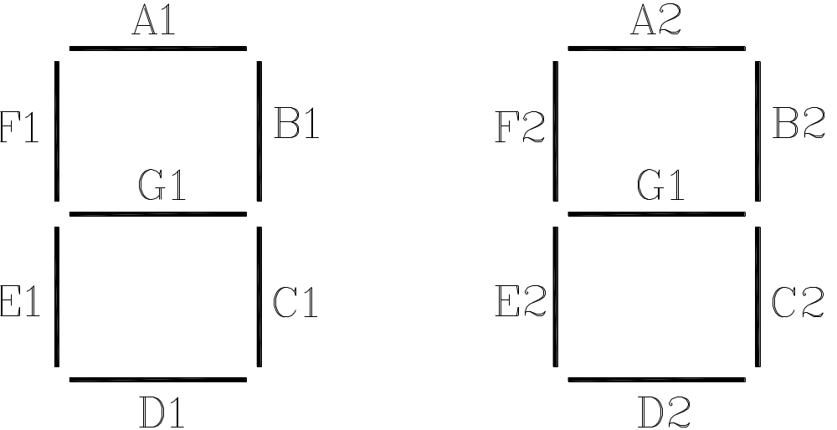
Figure 10: Self Test Error Display

Display | Possible Problem Location(s)
A1 | Film Carriage Safety Bar
A1 | EMERGENCY STOP button
A1 | Electrical enclosure safety switch
B1 | Film carriage max upper limit switch
C1 | Film carriage max down limit switch
D1 | Turntable count/home proximity switch
E1 | BANDING push button
F1 | START push button
G1 | Package height photo sensor
A2 | START light
B2 | Turntable motor
C2 | Carriage motor

Additional INFO Messages
During normal machine operation, the following messages might be displayed:

EO = Emergency Stop condition
- - = System is normal
- - = Blinking = Power supply is bad or both carriage up and down limit switch inputs are on
A = Mode A is selected
B = Mode B is selected
CO = Continue operation by pushing START button
S = System is in Manual

Troubleshooting Guide

Warning!
Make sure that only qualifies personnel will perform inspection, troubleshooting, and part replacement.

High Voltage!
Disconnect all power including external control power that may be present before servicing the machine. Wait 3 (three) minutes for the microcontroller card to fully discharge. The machine INFO and/or LED’s are not accurate indicators of the absence of voltage.

The diagrams in this section will guide you in identifying typical problems while operating the Predator Turntable Stretch Wrapper, and provide you with corresponding solution(s). Problems are divided in reference to the machine functions: power, turntable, and film carriage.

If further assistance is required, contact the distributor from whom you have purchased the equipment, or call the number listed on the bottom page of this manual. To receive quick and proper technical support, please be prepared to provide the following information:
- Machine serial number
- Date of purchase
- Symptoms of any problem

Power Problems
Problem | Possible Cause | Possible Solution
The machine does not power up. (INFO screen is blank) | The machine is not plugged in. | Plug the machine into a 120VAC, 20A outlet.
The machine does not power up. (INFO screen is blank) | The Main Disconnect is turned off. | Turn the Main Disconnect on.
The machine does not power up. (INFO screen is blank) | A fuse is blown. | Replace the fuse(s).
The machine does not power up. (INFO screen is blank) | The power supply has malfunctioned. | Ensure fuses F6 and F7 are not blown. Replace the power supply (transformer card).
The machine does not power up. (INFO screen is blank) | Power to the machine is not correct | Use a voltmeter to check that the machine is receiving 120VAC.
The INFO display shows E0 | The Emergency Stop button is pressed. | Turn the breaker back on, or replace if necessary.
The INFO display shows E0 | The film carriage foot safety switch is tripped. | Remove any obstructions and check that the switch is working properly.
The INFO display shows E0 | The electrical enclosure door switch is open. | Ensure the door is closed and that the safety switch is made.
The INFO display is flashing ‘- -‘ | The power supply has malfunctioned. | Ensure fuses F6 and F7 are not blown. Replace the power supply (transformer card).
The INFO display is flashing ‘- -‘ | The carriage raised/lowered limit switches are both tripped. | Ensure there are no obstructions and that the switches are working properly.

Turntable Problems
Problem | Possible Cause | Possible Solution
The turntable does not rotate manually. | The Start Button was not pressed. | The Start button needs to be pressed at the same time as the turntable job button to activate manual mode.
The turntable does not rotate manually. | The Turntable speed potentiometer is not set high enough. | Adjust the turntable speed towards 100%.
The turntable does not rotate manually. | The turntable is mechanically restricted. | Check the condition of the motor, chain, and rollers under the turntable. Replace as necessary.
The turntable does not rotate manually. | The turntable speed potentiometer has failed. | Use a multi-meter to check the resistance of the potentiometer.
The turntable does not rotate manually. | A fuse on the microcontroller card has blown. | Check fuses and replace as needed.
The turntable does not rotate manually. | The motor is not wired correctly. | Check wiring to the motor and replace as necessary.
The turntable does not stop at home. | The Turntable Home proximity switch is malfunctioning. | Check the wiring to the proximity switch and that it is adjusted properly (only 8mm sensing range). Replace as necessary.

Film Carriage Problems
Problem | Possible Cause | Possible Solution
The Film Carriage does not Raise or Lower manually or in the wrap cycle. | The Start Button was not pressed. | The Start button needs to be pressed at the same time as the carriage raise/lower button to activate manual mode.
 | The Carriage Banding button is tripped. | Ensure the banding button is not tripped and that the button is working properly.
 | The Film Carriage Raised/Lowered limit switch is malfunctioning. | Ensure that the carriage limit switch is clear of any obstruction and moves smoothly. Check wiring to the limit switch and replace as necessary.
 | The film carriage speed potentiometer is not set high enough. | Adjust the speed potentiometer towards 100%.
 | The film carriage speed potentiometer has failed. | Use a multi-meter to check the resistance of the potentiometer.
 | A fuse on the microcontroller card has blown. | Check fuses and replace as needed.
 | The motor is not wired correctly. | Check wiring to the motor and replace as necessary.
The Film Carriage rises some, but does not rise to the top of the package. | The Product Height Detection photo eye is positioned too high. | Slide the Product Height Detection photo eye lower.
 | The Product Height Detection photo eye does not see the load. | Black or clear loads may require an optional ultrasonic sensor instead of the standard diffuse sensor.
 |  | Check wiring to the sensor.
 |  | Replace the sensor as necessary.
 | The Product Height Detection photo eye is not adjusted properly. | Adjust position or sensitivity of the sensor.
The Film Carriage rises too far above the package. | The Product Height Detection photo eye is positioned too low. | Slide the Product Height Detection photo eye higher.
The Film Carriage rises too far above the package. | The Product Height Detection photo eye is not adjusted properly and always sees a ’package’. | Adjust the sensitivity of the sensor (see the Photo Sensor Adjustments and/or Pre-Operation Adjustments section).

7
Highlight Industries, Inc.
Predator SS Turntable Stretch Wrapper Operation Manual
Technical References

Recommended Spare Parts
The table below provides the recommended spare parts list for the Predator SS Turntable Stretch Wrapper.

Machine Section | HLI Part Number | Item Description | Qty
Turntable | 300013 | BELT B-172 | 1
Turntable | 500010 | PLASTIC SUPPORT WHEEL | 6
Turntable | 300037 | TURNTABLE DRIVE MOTOR – 1/4HP (60” dia turntable) | 1
Turntable | 300040 | TURNTABLE DRIVE MOTOR – 1/2HP (72” dia turntable) | 1
Turntable | 300031 | TURNTABLE DRIVE REDUCER (60” dia turntable) | 1
Turntable | 300032 | TURNTABLE DRIVE REDUCER (72” dia turntable) | 1
Tower | 300038 | CARRIAGE LIFT MOTOR – 1/4HP | 1
Tower | 300030 | CARRIAGE LIFT REDUCER | 1

Electrical Schematics
Electrical Drawings
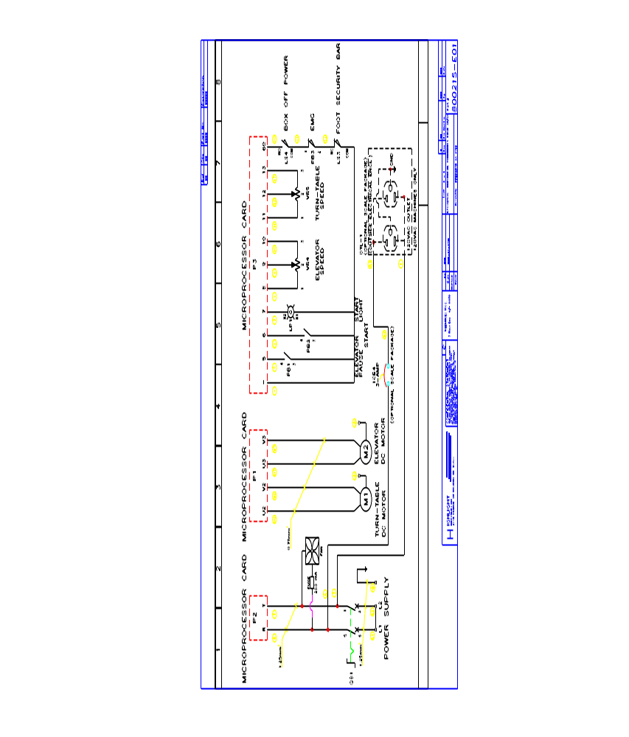
Electrical Schematics (continued) 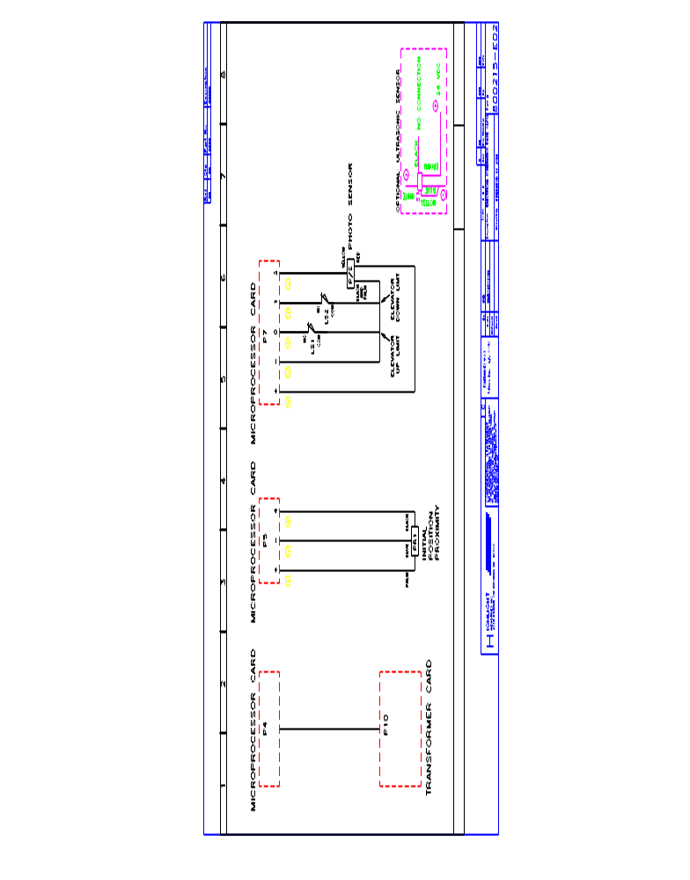Enclosure Layout
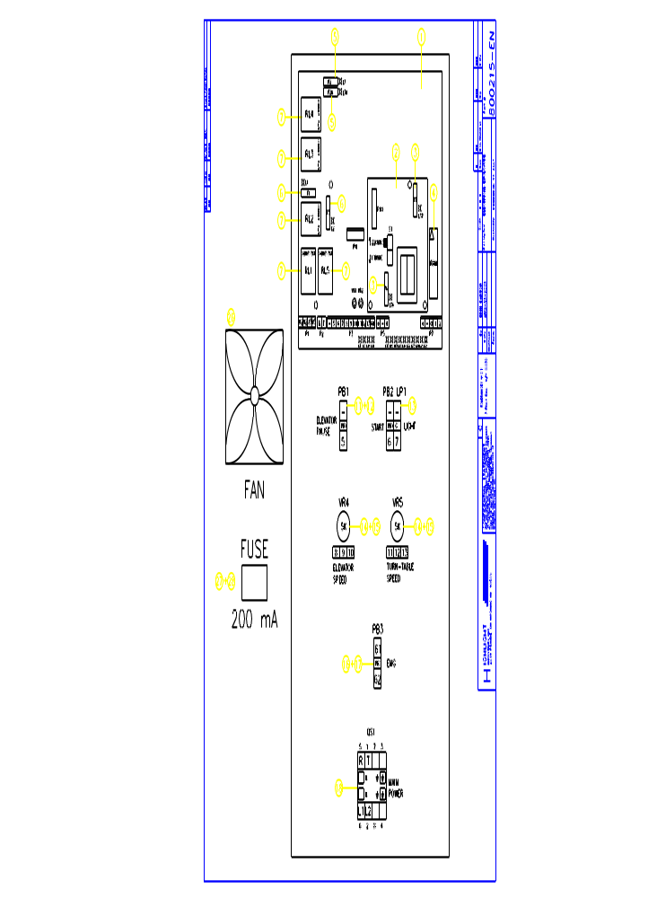
Sensor Layout
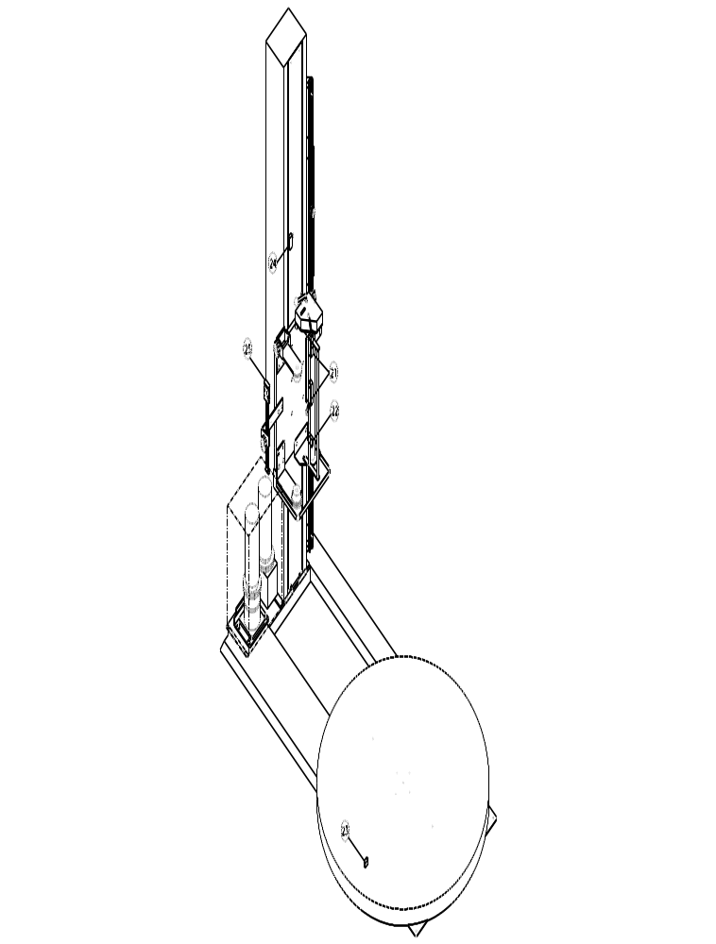
Electrical Parts List
Machine Section | HLI Part Number |  | Item Description |  | Qty
1 |  | 401495 |  | MICROPROCESSOR CARD |  | 1
2 |  | 401361 |  | TRANSFORMER CARD |  | 1
3 |  | 401362 |  | FUSE, 250 VAC, 1 AMP, GMA |  | 2
4 |  | 401363 |  | EPROM |  | 1
5 |  | 403261 |  | FUSE, 250 VAC, 10 AMP, GMA |  | 2
6 |  | 401365 |  | FUSE, 250 VAC, 5 AMP, GMA |  | 2
7 |  | 401366 |  | RELAY LY2 DC24V |  | 5
11 |  | 401367 |  | BUTTON WHITE |  | 1
12 |  | 401368 |  | BUTTON SEAT CONTACTOR Nox1 |  | 1
13 |  | 401369  401370  400611 |  | AUTO RUN GREEN LAMP: COVER  SEAT  LIGHT |  | 1  1  1
14 |  | 401371 |  | KNOB RN-99F,ø6.4 |  | 2
15 |  | 400649 |  | VARIOUS RESISTOR 5K |  | 2
16 |  | 401372 |  | EMG. SWITCH |  | 1
17 |  | 401373 |  | BUTTON SEAT CONTACTOR NCx1 |  | 1
18 |  | 401374 |  | MAIN POWER SWITCH |  | 1
21 |  | 400639 |  | LIMIT SWITCH TZ-8108 |  | 2
22 |  | 400636 |  | LIMIT SWITCH TM-1307 |  | 1
23 |  | 400641 |  | PROXIMITY SWITCH PS-05N-3M |  | 1
24 |  | 400637 |  | LIMIT SWITCH TZ-7110 |  | 1
25 |  | 400643 |  | PHOTO SENSOR A3R-2MX(OPTION) |  | 1
26 |  | 404261 |  | FAN, 80MM, 110-120VAC |  | 1
27 |  | 404262 |  | FUSE HOLDER |  | 1
28 |  | 404263 |  | FUSE, 0.2A, 30MM |  | 1
N/S |  | 310008 |  | BUTTON MEMBRANE LABEL FOR CONTROL PANEL |  | 1
N/S |  | 403409 |  | CARRIAGE CONTROL CABLE |  | 1

Mechanical Drawings
Turntable Frame Assembly
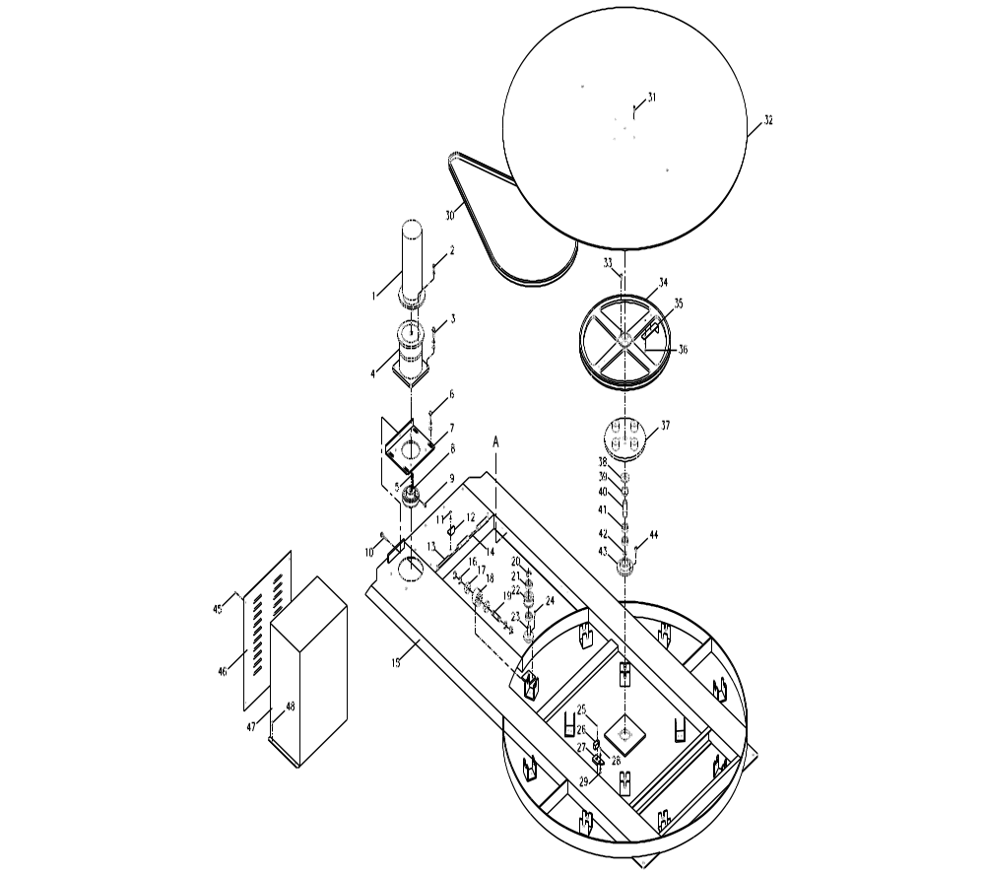
Turntable Parts List

Machine Section | HLI Part Number | Item Description | Qty
1 | 300037  300040 | MOTOR VP3310D 1/4HP →1.5M  MOTOR VP3330D 1/2HP →1.8M | 1  1
2 | 200091 | SCREW M8X20L & W.
3 | 200092 | SCREW M10x20L & S.W. & W. | 4
4 | 300031  300032 | SPEED REDUCER 1/4HP →1.5M  SPEED REDUCER 1/2HP →1.8M | 1  1
5 | 300002 | KEY 5X20L | 1
6 | 200093 | SCREW M10x25L & S.W. & W. | 4
7 | 500034  500035 | MOTOR ADJUST SEAT →1.5M  MOTOR ADJUST SEAT →1.8M | 1  1
8 | 500014  500015 | MOTOR PULLEY 4”22 →1.5M  MOTOR PULLEY 4”28 →1.8M | 1  1
9 | 207303 | SET SCREW, M8 x 10L | 2
10 | 200095 | SCREW M10x70L | 1
11 | 200077 | SCREW M6x12L & W. | 1
12 | 500083 | MOTOR BOX FIX PLATE | 1
13 | 500087 | PIN | 2
14 | 300006 | RING STW-10 | 2
15 | 600000  600001 | TURNTABLE SEAT 1.5M  TURNTABLE SEAT 1.8M | 1  1
16 | 300009 | RING STW-17 | 48
17 | 305300  305300 | BEARING 6203ZZ →1.5M  BEARING 6203ZZ →1.8M | 24  28
18 | 500010  500010 | SUPPORTING PLASTIC WHEEL →1.5M  SUPPORTING PLASTIC WHEEL →1.8M | 12  14
19 | 500009  500009 | SUPPORTING PLASTIC WHEEL SHAFT →1.5M  SUPPORTING PLASTIC WHEEL SHAFT →1.8M | 12  14
20 | 300009 | RING STW-17 | 1
21 | 305300 | BEARING 6203ZZ | 2
22 | 500011 | BELT LOCK PULLEY | 1
23 | 500012 | BELT LOCK PULLEY SHAFT | 1
24 | 200078 | SCREW M6x16L | 3
25 | 200098 | SCREW M3x25L & W. | 2
26 | 400641 | PROXIMITY SWITCH PS-05N-3M | 1
27 | 500013 | PROXIMITY SWITCH FIX SEAT | 1
28 | 200103 | SCREW M4x20L | 2
29 | 200128 | NUT M5 | 6
30 | 300013  300014 | BELT B-172 →1.5M  BELT B-183 →1.8M | 1  1
31 | 200113 | SCREW M8x25L | 4
32 | 500004  500005 | TURNTABLE PLATE 1.5M  TURNTABLE PLATE 1.8M | 1  1
33 | 200084 | SCREW M8x20L | 4
34 | 500007 | WHEEL 22” | 1
35 | 500006 | LOCATING PLATE | 1
36 | 200108 | SCREW M5x10L & W. | 4
37 | 500008 | PULLEY FIXING PLATE | 1
38 | 500085 | BELT PULLEY SEAT RING | 1
39 | 300012 | RING RTW-42 | 1
40 | 500084 | BELT PULLEY SHAFT | 1
41 | 300018 | BEARING 6004ZZ | 2
42 | 300010 | RING STW-20 | 1
43 | 500086 | BELT PULLEY BEARING SEAT | 1
44 | 200088 | SCREW M10x16L | 4
45 | 200100 | SCREW M4x8L & W. | 4
46 | 500081  500082 | MOTOR COVER →1.5M  MOTOR COVER →1.8M | 1  1
47 | 600028  600029 | TURNTABLE MOTOR BOX 1.5M  TURNTABLE MOTOR BOX 1.8M | 1  1
48 | 200100 | SCREW M4x8L & W. | 2
Tower Assembly
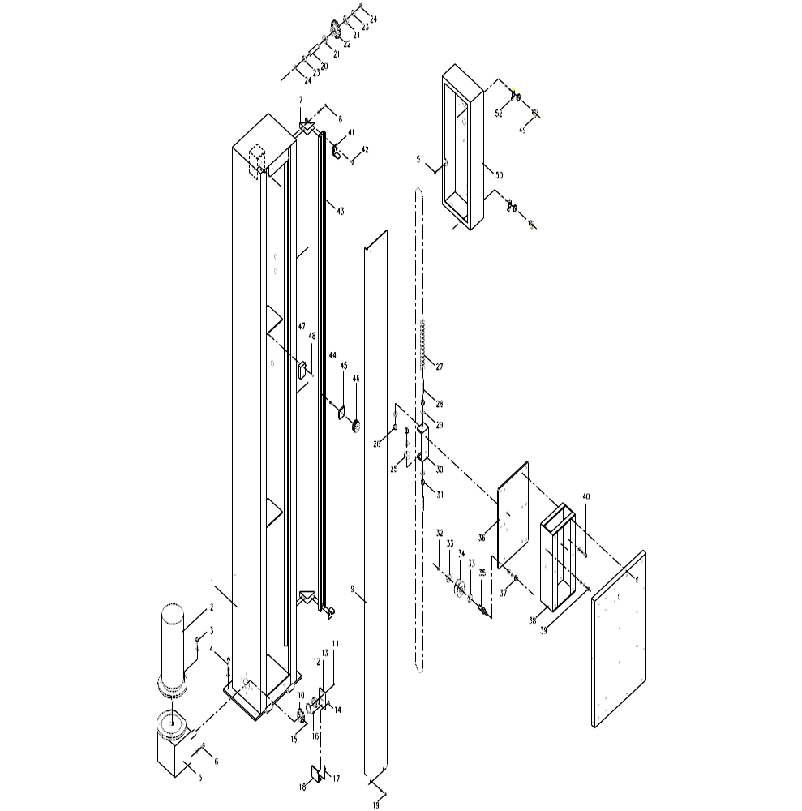
Tower Parts List

Machine Section | HLI Part Number | Item Description | Qty
1 | 500133  500134 | TOWER 2.1M  TOWER 2.6M | 1  1
2 | 300038 | ELEVATOR UNIT MOTOR VP3310D | 1
3 | 200091 | SCREW M8x20L & S.W. | 4
4 | 200090 | SCREW M10x25L & S.W. & W. | 5
5 | 300030 | ELEVATOR UNIT SPEED REDUCER VTM-40 | 1
6 | 200085 | SCREW M8x25L & S.W. & W. | 4
7 | 500135 | CHANNEL SUPPORT | 2
8 | 200078 | SCREW M6x16L & S.W. & W. | 4
9 | 500136  500137 | CHAIN WHEEL COVER 2.1M  CHAIN WHEEL COVER 2.6M | 1  1
10 | 500090 | UP & DOWN CHAIN WHEEL (LOWER) 11 TEETH | 1
11 | 200099 | SCREW M4x6L & W. | 2
12 | 300020 | BEARING 6202-2NR | 1
13 | 500102 | SPEED REDUCER BEARING SEAT | 1
14 | 200076 | SCREW M6x10L & W. | 2
15 | 200120 | SCREW M6x8L | 1
16 | 300000 | PIN ø4X8 | 1
17 | 200082 | SCREW M8x12L | 2
18 | 500103 | BEARING ADJUST SEAT | 1
19 | 200077 | SCREW M6x12L & W. | 4
20 | 500003 | UPPER CHAIN WHEEL SHAFT | 1
21 | 300017 | BEARING 6002ZZ | 2
22 | 500089 | UPPER CHAIN WHEEL | 1
23 | 500093 | RING | 2
24 | 300008 | RING STW-15 | 2
25 | 500104 | ADJUST BAR WASHER | 1
26 | 200140 | NUT M12 | 1
27 | 300049  300050 | CHAIN→2.1M  CHAIN→2.6M | 1  1
28 | 500025 | ELEVATOR UNIT CHAIN SCREW SHAFT | 2
29 | 200147 | WASHER M12 | 4
30 | 500092 | CHAIN ADJUST SEAT | 1
31 | 200133 | NUT M12 | 3
32 | 300007 | RING STW-12 | 6
33 | 300016 | BEARING 6001ZZ | 8
34 | 500090 | UP & DOWN DRIVING WHEEL | 4
35 | 500091 | UP & DOWN DRIVING WHEEL SHAFT | 4
36 | 500040 | CHAIN WHEEL SEAT | 1
37 | 200131 | NUT M10 & S.W. & W. | 6
38 | 600008 | ELEVATOR UNIT SEAT (INNER) | 1
39 | 200084 | SCREW M8x20L & S.W. & W. | 2
40 | 200083 | SCREW M8x16L & S.W. & W. | 6
41 | 500138 | LIMIT PLATE | 2
42 | 200125 | SCREW M6x16L & S.W & NUT | 4
43 | 500139  500140 | CHANNEL 2.1M  CHANNEL 2.6M | 1  1
44 | 200078 | SCREW M6x16L | 1
45 | 500141 | FIX PIECE | 1
46 | 500142 | HANDEL WHEEL | 1
47 | 400637 | LIMIT SWITCH TZ-7110 | 1
48 | 200105 | SCREW M4x30L & W | 2
49 | 300041 | LOCK w/ KEY | 2
50 | 500143 | CONTROL BOX | 1
50a | 310008 | BUTTON MEMBRANE LABEL FOR CONTROL PANEL | 1
51 | 200076 | SCREW M6x10L & S.W. | 1
52 | 300048 | LOCK LATCH PLATE | 2

Film Carriage Assembly

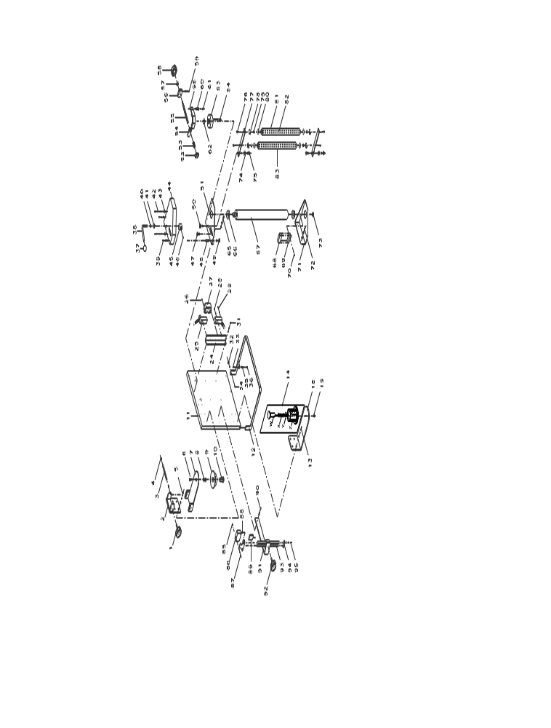
Film Carriage Parts List
Machine Section | HLI Part Number | Item Description | Qty
1 | 500000 | HANDLE | 1
2 | 500144 | FILM FIX SEAT(UPPER) | 1
3 | 500145 | SHAFT | 1
4 | 300006 | RING STW-10 | 2
5 | 200079 | SCREW M6*20L & S.W. & W. | 4
6 | 200089 | SCREW M10*20L | 1
7 | 500146 | FILM MOVING SHAFT | 1
8 | 500147 | FILM SEAT SPRING | 1
9 | 500148 | FILM SEAT(UPPER) | 1
10 | 500101 | FILM SEAT SHAFT | 1
11 | 500149  504260 | ELEVATOR UNIT SEAT(OUTER)-20”  ELEVATOR UNIT SEAT(OUTER)-30” | 1  1
12 | 500150 | PEDAL | 1
13 | 200079 | SCREW M6*20L & S.W. & W. | 4
14 | 700072 | LOWER CORE HOLDER ASSEMBLY | 1
 | W | FILM SEAT SHAFT
 | X | SPRING
 | Y | BEARING NTB/A51730
 | Z – 500107 | FILM FIX SEAT
 | Za – 500111 | BRAKE
 | Zb – 500109 | FILM BRAKE PLATE
 | Zd – 500112 | WASHER
18 | 500151 | FILM FIX SEAT(LOWER) | 1
19 | 200089 | SCREW M10*20L | 1
23 | 200079 | SCREW M6*20L & S.W. & W. | 2
24 | 500152 | LIMIT SWITCH SEAT | 1
25 | 400639 | LIMIT SWITCH TZ-8108 | 2
26 | 200101 | SCREW M4*12L | 2
27 | 500130 | TERMINAL COVER | 1
28 | 200102 | SCREW M4*16L | 4
29 | 200101 | SCREW M4*12L | 4
31 | 200077 | SCREW M6*12L & S.W. & W. | 2
32 | 200137 | NUT M6 | 2
33 | 200103 | SCREW M4*20L | 1
34 | 200079 | SCREW M6*20L | 2
35 | 500016 | SPRING | 1
36 | 200127 | NUT M4 | 2
37 | 500913 | HANDLE KNOB | 1
38 | 500153 | HANDLE | 1
39 | 200077 | SCREW M6*12L & S.W. & W. | 2
40 | 300006 | RING STW-10 | 1
41 | 500154 | RING | 1
42 | 200157 | SCREW M6*100L | 2
43 | 200129 | NUT M6 | 4
44 | 500155 | STRETCH SEAT COVER(UPPE) | 1
45 | 500156 | WHEEL | 1
46 | 200121 | SCREW M6*10L | 1
47 | 200130 | NUT M8 & S.W. | 2
48 | 500157 | STRETCH SEAT SHAFT | 1
49 | 200130 | NUT M8 & W. | 1
50 | 500158 | RING | 1
51 | 500159 | UPPER STRETCH SEAT | 1
52 | 500160 | TENSION ADJUST SEAT | 1
53 | 500161 | STRETCH SPRING | 1
54 | 500162 | BRAKE PLATE | 1
55 | 500163 | TENSION ADJUST SCREW | 1
56 | 500164 | GEAR SCREW FIX SEAT | 1
57 | 500154 | RING | 1
58 | 500000 | HANDLE | 1
59 | 200077 | SCREW M6*12L & S.W. & W. | 2
60 | 500165 | BREAK PLATE SHAFT | 1
61 | 200129 | NUT M6 & S.W. | 2
62 | 500166 | BREAK WHEEL FIX SHAFT | 1
63 | 500167 | BRAKE WHEEL | 1
64 | 300002 | PIN 5*5*20L | 1
65 | 200084 | SCREW M8*20L & S.W. & W. | 2
66 | 300051 | BEARING 6004ZZ-NR | 2
67 | 500168  504261 | PRE-STRETCH SHAFT-20”  PRE-STRETCH SHAFT-30” | 1  1
68 | 400640 | WIRE PROTECTOR | 1
69 | 400636 | LIMIT SWITCH TM-1307 | 1
70 | 200104 | SCREW M4*25L | 2
71 | 500169 | LOWER STRETCH SEAT | 1
72 | 200084 | SCREW M8*20L & S.W. & W. | 2
73 | 300010 | RING STW-20 | 1
74 | 500158 | RING | 2
75 | 500170 | MOVING SHAFT PIN | 2
76 | 200833 | SCREW M6*12L | 4
77 | 500171  500172 | MOVING SHAFT  MOVING SHAFT | 1  1
78 | 300052 | RING STW-22 | 4
79 | 300006 | RING STW-10 | 4
80 | 300015 | BEARING 6000ZZ | 4
81 | 500173  504262 | IDLER ROLLER-20”  IDLER ROLLER-30” | 1  1
82 | 500174  504263 | IDLER ROLLER SHAFT-20”  IDLER ROLLER SHAFT-30” | 2  2
83 | 500175  504264 | IDLER ROLLER-20”  IDLER ROLLER-30” | 1  1
85 | 200127 | NUT M4 (OPTION) | 2
86 | 400643 | PHOTO SENSOR A3R-2MX (OPTION) | 1
87 | 200101 | SCREW M4x12L & W. (OPTION) | 2
88 | 200110 | SCREW M6x12L (OPTION) | 2
89 | 500094 | FIX PIECE (OPTION) | 1
90 | 200079 | SCREW M6*20L & S.W. & W. (OPTION) | 2
91 | 500176 | PHOTO SENSOR ADJUST SEAT (OPTION) | 1
92 | 500000 | HANDLER (OPTION) | 1
93 | 500095 | PHOTO SENSOR ADJUST BAR (OPTION) | 2
94 | 500096 | CONNECTING PLATE (OPTION) | 1
95 | 200077 | SCREW M6*12L & S.W. & W. (OPTION) | 2
96 | 304629 | SPACER, ANTI-SQUEAK | 1

8
Highlight Industries, Inc.
Predator SS Turntable Stretch Wrapper Operation Manual
Notes

